**Experiment 9**

**Aim/Overview of the practical:**

* Create and maintain cloud storage using File share?

**Code/Steps for the Practical:**

**Step 1)** Go to Azure portal and login with your credentials.

**Step 2)** Click on **“Create a Resource”** in the top left corner.

**Step 3)** From the left menu click on **Storage**.

**Step 4)** After that from the right click on **create** **Storage Account card.**

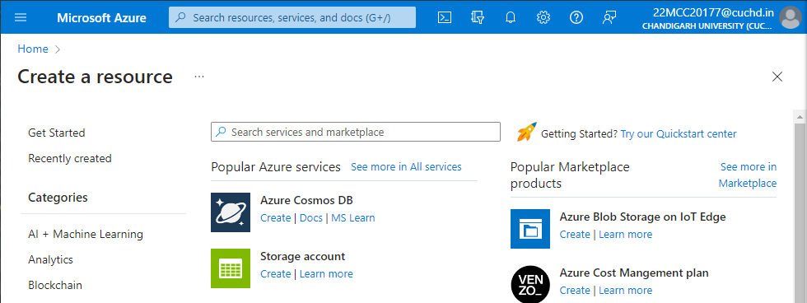

**Step 5)** A create a storage Account window will appear fill in all the details such as Resource group, Storage Account name, Region, and select premium in Performance, account type as file shares and Redundancy as LRS after all that click on **Review and create.**

**Step 6)** After deployment is finished click on **Go to Resource.**

**Step 7)** From the left menu select **File shares** under **Data Storage.**

**Step 8)** Then click on **+ File shares** button on the top to create a new file share.

**Step 9)** Give a name and size to your container and click on create.

**Step 10)** Select newly created file share drive and click on the **Upload** button on top to upload local files to azure cloud.

**Step 11)** A window will appear on the left side of screen **Drag and Drop or Browse files** which you want to upload into it and click on **the Upload** button.

**Step 12)** To connect this drive to your local system click on the C**onnect** button on the top left corner.

**Step 13)** A window will appear on the left side of screen. On that window select **your OS, give Drive letter** after that click on **show script**.

**Step 14)** After that right click on **this PC** on your local system and select **Map Network Drive.**

**Step 15)** A Popup Window will appear select Drive letter and in Folder paste user data from the show script and click on Finish.

**Step 16)** Anew network drive will appear on your Explorer.

**Step 17) N**ow you can use this drive as usual its sync with azure cloud.

**Step 18)** To Disconnect the drive right click on drive and click on disconnect.

**Learning Outcomes (What I have learned)**

* I Learned to: -
  + - * Create Storage resources in the azure portal.
      * Create a network drive.

**Evaluation Grid:**

|  |  |  |  |
| --- | --- | --- | --- |
| Sr. No. | Parameters | Marks Obtained | Maximum Marks |
| 1. | Demonstration and Performance (Quiz) |  | 22 |
| 2. | Worksheet |  | 8 |